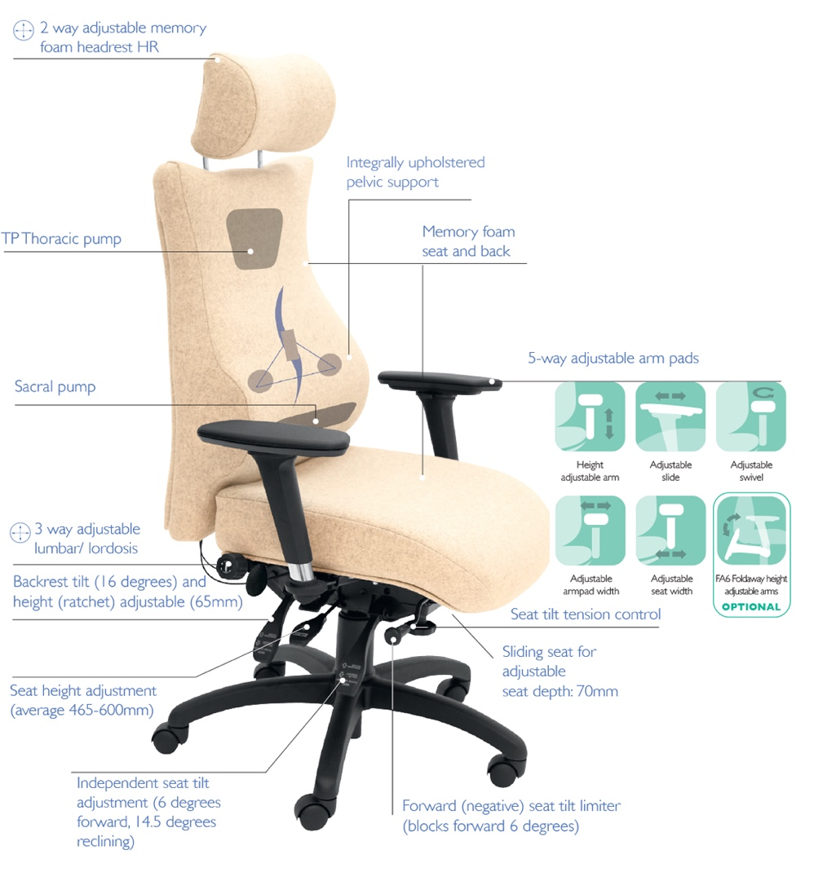
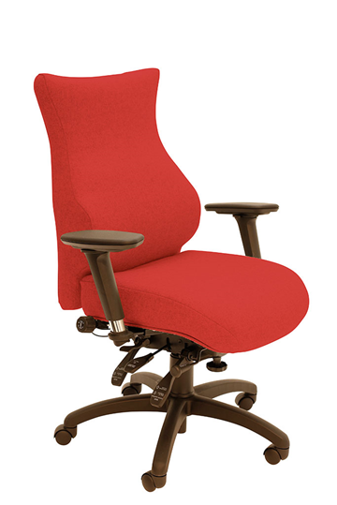
SD5 High Back with Headrest
SD4 High Back Model

Each of the chairs shown uses the same ingredients as the SD2/3 but does so with an all-in-one integral style of upholstery to ensure each part of the spine receives optimal support: pelvic (sacral) support through the preset pelvic module and sacral pump, lumbar through the height and depth adjustable lumbar cradle and lumbar air bag (3-way) assembly area and the shoulder height (thoracic) pump helps support the upper part of your back.
SD4 SD5
Chronic back pain seating
For more information and prices, please contact Phil Pask on 07803 120155
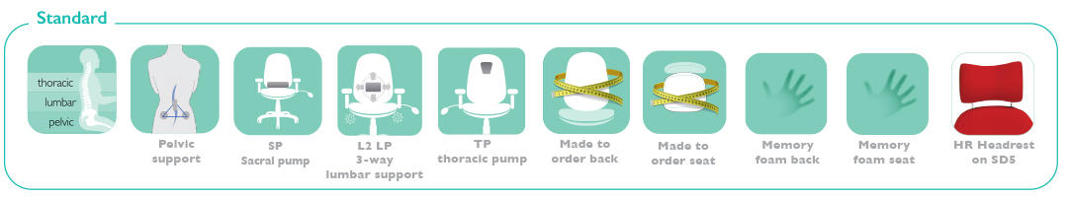

Other ergonomic features include:

- The triangulation of support provided by the integrally upholstered, preset pelvic cushion and the 3-way adjustable lumbar
- The sacral pump
- The Thoracic pump
- The use of memory foam in seat, back and headrest
- 6-way adjustable forward tilting mechanism: adjustable for seat tilt, depth, height, tension (weight) control, backrest height (ratchet) and tilt
- 6 seats to complement 2 back configurations including height and tilt adjustable headrest for custom built comfort
- 5-way adjustable PU arms; adjustable for: height, depth (forward and back), width and (lock-ing) swivel

